Discussion Assignment 6
- Do you think it is useful to have a theoretical model for a situation that occurs in real life? Justify.
Yes, I think it is useful to have a theoretical model for a situation that occurs in real life. Theoretical models can help us to:
- Understand complex systems: Theoretical models can help us to break down complex systems into simpler, more manageable components. This makes it easier to understand how individual parts interact and influence the overall system.
- Make predictions: Theoretical models can be used to make predictions about how a system will behave under different conditions. This can be very helpful in making decisions about how to manage or control the system.
- Identify areas for further research: Theoretical models can help us to identify areas where we need to learn more about a system. This can lead to new discoveries and innovations.
- When forming your answer to this question give an example of a situation from you own field of interest for which a random variable, possibly from one of the types that are presented in this unit, can serve as a model.
One example of a situation from education for which a random variable can serve as a model is student test scores. Student test scores can be modelled as a continuous random variable, such as a normal distribution. This means that the scores can take on any value within a certain range, and the distribution of scores is bell-shaped, with the majority of scores falling near the middle of the range. The figure below shows a normal distribution graph presenting students SAT scores.
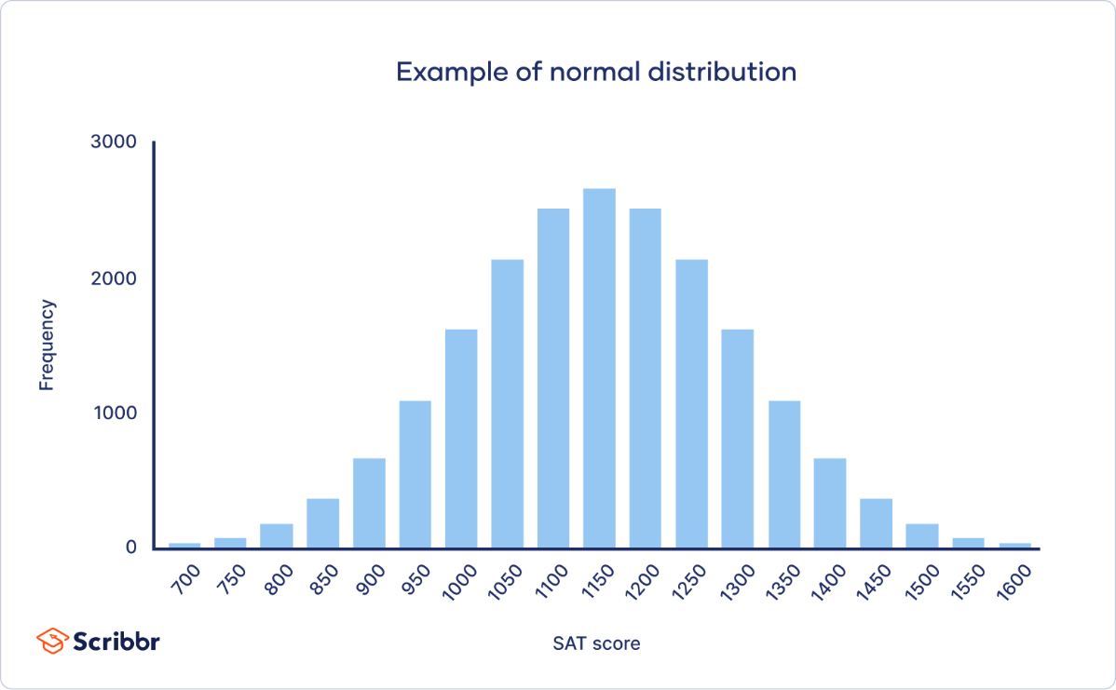
- Discuss the importance (or lack thereof) of having a theoretical model for the situation.
Having a theoretical model for student test scores is important because it allows us to make predictions about how students will perform on tests. For example, we can use the model to predict the percentage of students who will score above a certain threshold, or the probability that a particular student will score above or below a certain level.
The model can also be used to identify potential problems and solutions. For example, if the model shows that a large percentage of students are scoring below a certain threshold, this may indicate that there is a problem with the curriculum or that the students need more support.

